This week, MUSA is hosting…

**New Student Reception**

Thursday, September 15, 2016

1015 Evans, 5pm



**Math Monday Series**

Join MUSA and other math enthusiasts at our first Homework Party on **Wednesday, September 14 at 6:30pm in 939 Evans.** Work amongst your peers on your problem sets. Enjoy the provided snacks as you work together and ask each other about your courses. No matter what you're taking, chances are there will be somebody else who is taking or who has taken your class. And of course, enjoy the food!

We're already in the fourth week of the semester! Adjusting to Berkeley can be a bit challenging for some of us. As such, this **Thursday** MUSA is hosting a social night geared toward new students (**freshmen and junior transfers**). The event will begin at 5, with popsicles, followed by a chance for you to gain eternal wisdom from our very own undergraduate advisor **Thomas Brown.** Meet the **peer-advising team**, hear about various resources in the department, and form study groups for your classes while **playing board games and munching on snacks,**so stop by whenever you can!

**Homework Party**

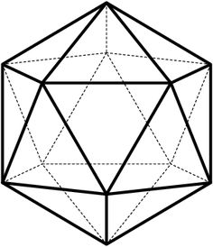

**Monday, September 19 from 5 to 6pm in 740 Evans**

**Speaker**: Julian Chaidez

**Title**: *Cutout Instructions and Geometric Invariants*.

**Abstract**: Suppose that you are given paper cutout instructions for a very large looking polyhedron, with many sides. How could you distinguish between a "real" set of instructions, which describes a polyhedron that can actually be constructed, and "fake" set of instructions, which appears valid at a glance but actually described an unbuildable shape? In this talk, I will discuss a way of proving that a set of instructions are "fake" by computing a geometric invariant of the polyhedron called the Euler characteristic. This talk will require no background.